**//Start.java**

import java.awt.*;

import java.awt.color.*;

import java.awt.event.*;

import javax.swing.*;

public class Start extends JFrame implements ActionListener

{

JTextField t1;

JPasswordField t2;

JButton b1;

public Start()

{

//JFrame

setTitle("ONLINE EXAMINATION");

setSize(1820,1100);

setLocationRelativeTo(null);

setDefaultCloseOperation(JFrame.EXIT_ON_CLOSE);

setVisible(true);

Font F= new Font("SansSerif",Font.ROMAN_BASELINE,20);

Font F1= new Font("SansSerif",Font.ITALIC,40);

setLayout(new FlowLayout());

//BackgroundImage

ImageIcon bg=new ImageIcon("C:\\Users\\shree\\Pictures\\l10.jpg");

JLabel l1=new JLabel(bg,JLabel.CENTER);

setSize(1700,1000);

add(l1);

// Login Label

Color c1=new Color(120,120,120,120);

JLabel j1=new JLabel("Student Login Panel");

j1.setBounds(430,100, 700,100);

j1.setFont(F1);

j1.setForeground(Color.BLACK);

j1.setBackground(c1);

l1.add(j1);

//JPanel

JPanel jp= new JPanel();

jp.setLayout(null);

jp.setBounds(250,200,700,750);

jp.setBackground(c1);

l1.add(jp);

//Logo

ImageIcon logo=new ImageIcon("C:\\Users\\shree\\Pictures\\user3.png");

JLabel l2=new JLabel(logo);

l2. setBounds(240,20,256,256);

jp.add(l2);

//Username Image

ImageIcon user=new ImageIcon("C:\\Users\\shree\\Pictures\\user1.0.png");

JLabel l3=new JLabel(user);

l3.setBounds(100,300,64,64);

// l3.setToolTipText("ENTER YOUR VALID USERNAME");

jp.add(l3);

//Username Textfieldt1=new JTextField();

t1.setBounds(180,310,350,40);

t1.setFont(F);

//t1.setToolTipText("ENTER YOUR VALID USERNAME");

jp.add(t1);

//Password Image

ImageIcon pass=new ImageIcon("C:\\Users\\shree\\Pictures\\pass.png");

JLabel l4=new JLabel(pass);

l4.setBounds(100,400,64,64);

l4.setToolTipText("ENTER YOUR VALID PASSWORD");

jp.add(l4);

//Password Textfield

t2=new JPasswordField();

t2.setBounds(180,410,350,40);

t2.setFont(F);

t2.setToolTipText("ENTER YOUR VALID PASSWORD");

jp.add(t2);

//Login Button

ImageIcon login=new ImageIcon("C:\\Users\\shree\\Pictures\\log.png");

b1=new JButton(login);

b1.setBounds(240,540,200,48);

b1.setToolTipText("LOGIN HERE...");

jp.add(b1);

b1.addActionListener(this);

}

public void login()

{

if(t1.getText().equals("admin")&&t2.getText().equals("admin"))

{

second sc=new second();

sc.setVisible(true);

setVisible(false);

}

else

{

JOptionPane.showMessageDialog(this,"OOPS....! Something Went Wrong...Please Check Your Username And Password");

}

}

public void actionPerformed(ActionEvent ae)

{

login();

}

public static void main (String args[])

{

Start s=new Start();

}

}

**//Second.java**

import java.awt.*;

import java.awt.event.ActionEvent;

import java.awt.event.ActionListener;

import javax.swing.*;

import javax.swing.border.EmptyBorder;

public class second extends JFrame implements ActionListener

{

JPanel contentPane;

public static void main(String[] args)

{

EventQueue.invokeLater(new Runnable()

{

public void run()

{

try

{

second frame = new second();

frame.setVisible(true);

}

catch (Exception e)

{

e.printStackTrace();

}

}

});

}

public int score=0;

JButton b1,b2;

JLabel l1,l2,l3,l4,l5,l6,l7,l8,l9,l10,sc;

Checkbox c1,c2,c3,c4,c5,c6,c7,c8,c9,c10,c11,c12,c13,c14,c15,c16,c17,c18,c19,c20,c21,c22,c23,c24,c25,c26,c27,c28,c29,c30,c31,c32,c33,c34,c35,c36,c37,c38,c39,c40;

JLabel jl,jl2;

JScrollPane jp;

Font F= new Font("SansSerif",Font.ITALIC,20);

Font F1= new Font("SansSerif",Font.BOLD,20);

public second()

{

setDefaultCloseOperation(JFrame.EXIT_ON_CLOSE);

setSize(1920,1200);

setVisible(true);

//BackgroundImage

ImageIcon bg=new ImageIcon("C:\\Users\\shree\\Pictures\\bg3.jpg");

jl=new JLabel(bg,JLabel.CENTER);

setSize(1920,1200);

jp=new JScrollPane(jl);

add(jp);

one();

}

public void one()

{

JOptionPane.showMessageDialog(this,"You Logged In Sucessfully...\r\n"+

"Instructions for Exam Candidate\r\n" +

"1. Exam has a total 10 questions (2 Marks each)\r\n" +

"2. Make sure you click the submit button to successfully complete the test.\r\n" +

"3. All Questions Are Mandatory.\r\n" +

"4. No Negative Marking.\r\n" +

"5. Use of Books, Notes & any other material is NOT ALLOWED");

//Question 1

l1=new JLabel("1) Which of the following option leads to the portability and security of Java? ");

l1.setFont(F1);

l1.setForeground(Color.RED);

l1.setBounds(100, 100, 1000,40);

jl.add(l1);

CheckboxGroup cb1= new CheckboxGroup();

c1= new Checkbox("a) Bytecode is executed by JVM",false,cb1);

c1.setFont(F);

c1.setBounds(100,140,1000,50);

jl.add(c1);

c2= new Checkbox("b) The applet makes the Java code secure and portable",false,cb1);

c2.setFont(F);

c2.setBounds(100,190,1000,50);

jl.add(c2);

c3= new Checkbox("c) Use of exception handling",false,cb1);

c3.setFont(F);

c3.setBounds(100,240,1000,50);

jl.add(c3);

c4= new Checkbox("d) Dynamic binding between objects",false,cb1);

c4.setFont(F);

c4.setBounds(100,290,1000,50);

jl.add(c4);

//Question 2

l2=new JLabel("2) Which of the following is not a Java features?");

l2.setFont(F1);

l2.setForeground(Color.RED);

l2.setBounds(100, 370, 1000,40);

jl.add(l2);

CheckboxGroup cb2= new CheckboxGroup();

c5= new Checkbox("a) Dynamic",false,cb2);

c5.setFont(F);

c5.setBounds(100,410,1000,50);

jl.add(c5);

c6= new Checkbox("b) Architecture Neutral",false,cb2);

c6.setFont(F);

c6.setBounds(100,450,1000,50);

jl.add(c6);

c7= new Checkbox("c) Use of pointers",false,cb2);

c7.setFont(F);

c7.setBounds(100,500,1000,50);

jl.add(c7);

c8= new Checkbox("d) Object-oriented",false,cb2);

c8.setFont(F);

c8.setBounds(100,550,1000,50);

jl.add(c8);

//Question 3

l3=new JLabel("3) _____ is used to find and fix bugs in the Java programs." );

l3.setFont(F1);

l3.setForeground(Color.RED);

l3.setBounds(100,630, 1000,40);

jl.add(l3);

CheckboxGroup cb3= new CheckboxGroup();

c9= new Checkbox("a) JVM",false,cb3);

c9.setFont(F);

c9.setBounds(100,670,1000,50);

jl.add(c9);

c10= new Checkbox("b) JRE",false,cb3);

c10.setFont(F);

c10.setBounds(100,710,1000,50);

jl.add(c10);

c11= new Checkbox("c) JDK",false,cb3);

c11.setFont(F);

c11.setBounds(100,750,1000,50);

jl.add(c11);

c12= new Checkbox("d) JDB",false,cb3);

c12.setFont(F);

c12.setBounds(100,800,1000,50);

jl.add(c12);

//Question 4

l4=new JLabel("4) Which of the following is a valid declaration of a char?" );

l4.setFont(F1);

l4.setForeground(Color.RED);

l4.setBounds(100,880, 1000,40);

jl.add(l4);

CheckboxGroup cb4= new CheckboxGroup();

c13= new Checkbox("a) char ch = '\\utea';",false,cb4);

c13.setFont(F);

c13.setBounds(100,910,1000,50);

jl.add(c13);

c14= new Checkbox("b) char ca = '\\tea';",false,cb4);

c14.setFont(F);

c14.setBounds(100,950,1000,50);

jl.add(c14);

c15= new Checkbox("c) char cr = \\u0223;",false,cb4);

c15.setFont(F);

c15.setBounds(100,1000,1000,50);

jl.add(c15);

c16= new Checkbox("d) char cc = '\\itea';",false,cb4);

c16.setFont(F);

c16.setBounds(100,1050,1000,50);

jl.add(c16);

JLabel j1=new JLabel("Page 1/3");

j1.setBounds(1350, 320, 200, 40);

j1.setFont(F1);

jl.add(j1);

b1=new JButton ("SUBMIT & NEXT");

b1.setBounds(1300, 370, 200, 40);

b1.setFont(F1);

b1.addActionListener(this);

jl.add(b1);

}

public void actionPerformed(ActionEvent e)

{

if(e.getSource()==b1)

{

if(c1.getState()==true)

{

score+=2;

c1.setState(true);

}

if(c2.getState()==true)

{

score+=0;

c2.setState(true);

}

if(c3.getState()==true)

{

score+=0;

c3.setState(true);

}

if(c4.getState()==true)

{

score+=0;

c4.setState(true);

}

if(c5.getState()==true)

{

score+=0;

c5.setState(true);

}

if(c6.getState()==true)

{

score+=0;

c6.setState(true);

}

if(c7.getState()==true)

{

score+=2;

c7.setState(true);

}

if(c8.getState()==true)

{

score+=0;

c8.setState(true);

}

if(c9.getState()==true)

{

score+=0;

c9.setState(true);

}

if(c10.getState()==true)

{

score+=0;

c10.setState(true);

}

if(c11.getState()==true)

{

score+=0;

c11.setState(true);

}

if(c12.getState()==true)

{

score+=2;

c12.setState(true);

if(c13.getState()==true)

{

score+=2;

c13.setState(true);

}

if(c14.getState()==true)

{

score+=0;

c14.setState(true);

}

if(c15.getState()==true)

{

score+=0;

c15.setState(true);

}

if(c16.getState()==true)

{

score+=0;

c16.setState(true);

}

third t=new third();

t.t1.setText(""+score);

t.t1.setVisible(false);

t.setVisible(true);

setVisible(false);

}

}

}

**//Third.java**

import java.awt.*;

import java.awt.event.ActionEvent;

import java.awt.event.ActionListener;

import javax.swing.*;

import javax.swing.border.EmptyBorder;

public class third extends JFrame implements ActionListener {

JPanel contentPane;

public static void main(String[] args)

{

EventQueue.invokeLater(new Runnable()

{

public void run()

{

try

{

second frame = new second();

frame.setVisible(true);

}

catch (Exception e)

{

e.printStackTrace();

}

}

});

}

int score=0;

JButton b1,b2,b3;

JLabel l1,l2,l3,l4,l5,l6,l7,l8,l9,l10,sc;

Checkbox c1,c2,c3,c4,c5,c6,c7,c8,c9,c10,c11,c12,c13,c14,c15,c16,c17,c18,c19,c20,c21,c22,c23,c24,c25,c26,c27,c28,c29,c30,c31,c32,c33,c34,c35,c36,c37,c38,c39,c40;

JLabel jl,jl2;

JScrollPane jp;

JTextField t1;

Font F= new Font("SansSerif",Font.ITALIC,20);

Font F1= new Font("SansSerif",Font.BOLD,20);

public third()

{

setDefaultCloseOperation(JFrame.EXIT_ON_CLOSE);

setSize(1920,1200);

setVisible(true);

//BackgroundImage

ImageIcon bg=new ImageIcon("C:\\Users\\shree\\Pictures\\bg3.jpg");

jl=new JLabel(bg,JLabel.CENTER);

setSize(1920,1200);

jp=new JScrollPane(jl);

add(jp);

one();

}

public void one()

{

//Question 5

l1=new JLabel("5) Which of the following creates a List of 3 visible items and multiple selections abled? ");

l1.setFont(F1);

l1.setForeground(Color.RED);

l1.setBounds(100, 100, 1000,40);

jl.add(l1);

CheckboxGroup cb1= new CheckboxGroup();

c1= new Checkbox("a) new List(false, 3)",false,cb1);

c1.setFont(F);

c1.setBounds(100,140,1000,50);

jl.add(c1);

c2= new Checkbox("b) new List(3, true)",false,cb1);

c2.setFont(F);

c2.setBounds(100,190,1000,50);

jl.add(c2);

c3= new Checkbox("c) new List(true, 3)",false,cb1);

c3.setFont(F);

c3.setBounds(100,240,1000,50);

jl.add(c3);

c4= new Checkbox("d) new List(3, false)",false,cb1);

c4.setFont(F);

c4.setBounds(100,290,1000,50);

jl.add(c4);

//Question

l2=new JLabel("6) Which of the following for loop declaration is not valid?");

l2.setFont(F1);

l2.setForeground(Color.RED);

l2.setBounds(100, 370, 1000,40);

jl.add(l2);

CheckboxGroup cb2= new CheckboxGroup();

c5= new Checkbox("a)for ( int i = 99; i >= 0; i / 9 )",false,cb2);

c5.setFont(F);

c5.setBounds(100,410,1000,50);

jl.add(c5);

c6= new Checkbox("b) for ( int i = 7; i <= 77; i += 7 )",false,cb2);

c6.setFont(F);

c6.setBounds(100,450,1000,50);

jl.add(c6);

c7= new Checkbox("c) for ( int i = 20; i >= 2; - -i )",false,cb2);

c7.setFont(F);

c7.setBounds(100,500,1000,50);

jl.add(c7);

c8= new Checkbox("d) for ( int i = 2; i <= 20; i = 2* i )",false,cb2);

c8.setFont(F);

c8.setBounds(100,550,1000,50);

jl.add(c8);

//Question7

l3=new JLabel("7) In which process, a local variable has the same name as one of the instance variables?");

l3.setFont(F1);

l3.setForeground(Color.RED);

l3.setBounds(100,630, 1020,40);

jl.add(l3);

CheckboxGroup cb3= new CheckboxGroup();

c9= new Checkbox("a) Serialization",false,cb3);

c9.setFont(F);

c9.setBounds(100,670,1000,50);

jl.add(c9);

c10= new Checkbox("b) Variable Shadowing",false,cb3);

c10.setFont(F);

c10.setBounds(100,710,1000,50);

jl.add(c10);

c11= new Checkbox("c) Abstraction",false,cb3);

c11.setFont(F);

c11.setBounds(100,750,1000,50);

jl.add(c11);

c12= new Checkbox("d) Multi-threading",false,cb3);

c12.setFont(F);

c12.setBounds(100,800,1000,50);

jl.add(c12);

//Question 8

l4=new JLabel("8) Which package contains the Random class?");

l4.setFont(F1);

l4.setForeground(Color.RED);

l4.setBounds(100,880, 1000,40);

jl.add(l4);

CheckboxGroup cb4= new CheckboxGroup();

c13= new Checkbox("a) java.util package",false,cb4);

c13.setFont(F);

c13.setBounds(100,910,1000,50);

jl.add(c13);

c14= new Checkbox("b) java.lang package",false,cb4);

c14.setFont(F);

c14.setBounds(100,950,1000,50);

jl.add(c14);

c15= new Checkbox("c) java.awt package",false,cb4);

c15.setFont(F);

c15.setBounds(100,1000,1000,50);

jl.add(c15);

c16= new Checkbox("d) java.io package",false,cb4);

c16.setFont(F);

c16.setBounds(100,1050,1000,50);

jl.add(c16);

JLabel j1=new JLabel("Page 2/3");

j1.setBounds(1350, 320, 200, 40);

j1.setFont(F1);

jl.add(j1);

b1=new JButton ("SUBMIT & NEXT ");

b1.setBounds(1300, 370, 200, 40);

b1.setFont(F1);

b1.addActionListener(this);

jl.add(b1);

t1=new JTextField("");

t1.setBounds(1440, 420, 200, 40);

jl.add(t1);

}

public void actionPerformed(ActionEvent e)

{

if(e.getSource()==b1)

{

if(c1.getState()==true)

{

score+=0;

c1.setState(true);

}

if(c2.getState()==true)

{

score+=2;

c1.setState(true);

}

if(c3.getState()==true)

{

score+=0;

c3.setState(true);

}

if(c4.getState()==true)

{

score+=0;

c4.setState(true);

}

if(c5.getState()==true)

{

score+=2;

c5.setState(true);

}

if(c6.getState()==true)

{

score+=0;

c6.setState(true);

}

if(c7.getState()==true)

{

score+=0;

c7.setState(true);

}

if(c8.getState()==true)

{

score+=0;

c8.setState(true);

}

if(c9.getState()==true)

{

score+=0;

c9.setState(true);

}

if(c10.getState()==true)

{

score+=2;

c10.setState(true);

}

if(c11.getState()==true)

{

score+=0;

c11.setState(true);

}

if(c12.getState()==true)

{

score+=0;

c12.setState(true);

}

if(c13.getState()==true)

{

score+=2;

c13.setState(true);

}

if(c14.getState()==true)

{

score+=0;

c14.setState(true);

}

if(c15.getState()==true)

{

score+=0;

c15.setState(true);

}

if(c16.getState()==true)

{

score+=0;

c16.setState(true);

}

int num=Integer.parseInt(t1.getText());

fourth f=new fourth();

f.t1.setText(""+(num+score));

f.t1.setVisible(false);

f.setVisible(true);

setVisible(false);

}

}

**}**

**//Fourth.java**

import java.awt.*;

import java.awt.event.ActionEvent;

import java.awt.event.ActionListener;

import javax.swing.*;

import javax.swing.border.EmptyBorder;

public class fourth extends JFrame implements ActionListener {

JPanel contentPane;

public static void main(String[] args)

{

EventQueue.invokeLater(new Runnable()

{

public void run()

{

try

{

second frame = new second();

frame.setVisible(true);

}

catch (Exception e)

{

e.printStackTrace();

}

}

});

}

public int score=0;

JButton b1,b2,b3;

JLabel l1,l2,sc;

JTextField t1;

Checkbox c1,c2,c3,c4,c5,c6,c7,c8;

JLabel jl,jl2;

JScrollPane jp;

Font F= new Font("SansSerif",Font.ITALIC,20);

Font F1= new Font("SansSerif",Font.BOLD,20);

public fourth()

{

setDefaultCloseOperation(JFrame.EXIT_ON_CLOSE);

setSize(1920,1200);

setVisible(true);

//BackgroundImage

ImageIcon bg=new ImageIcon("C:\\Users\\shree\\Pictures\\bg3.jpg");

jl=new JLabel(bg,JLabel.CENTER);

setSize(1920,1200);

jp=new JScrollPane(jl);

add(jp);

one();

}

public void one()

{

//Question 9

l1=new JLabel("9) What do you mean by nameless objects?");

l1.setFont(F1);

l1.setForeground(Color.RED);

l1.setBounds(100, 100, 1000,40);

jl.add(l1);

CheckboxGroup cb1= new CheckboxGroup();

c1= new Checkbox("a) An object created by using the new keyword.",false,cb1);

c1.setFont(F);

c1.setBounds(100,140,1000,50);

jl.add(c1);

c2= new Checkbox("b) An object of a superclass created in the subclass.",false,cb1);

c2.setFont(F);

c2.setBounds(100,190,1000,50);

jl.add(c2);

c3= new Checkbox("c) An object without having any name but having a reference.",false,cb1);

c3.setFont(F);

c3.setBounds(100,240,1000,50);

jl.add(c3);

c4= new Checkbox("d) An object that has no reference.",false,cb1);

c4.setFont(F);

c4.setBounds(100,290,1000,50);

jl.add(c4);

//Question 10

l2=new JLabel("10) An interface with no fields or methods is known as a ______.");

l2.setFont(F1);

l2.setForeground(Color.RED);

l2.setBounds(100, 370, 1000,40);

jl.add(l2);

CheckboxGroup cb2= new CheckboxGroup();

c5= new Checkbox("a) Runnable Interface",false,cb2);

c5.setFont(F);

c5.setBounds(100,410,1000,50);

jl.add(c5);

c6= new Checkbox("b) Marker Interface",false,cb2);

c6.setFont(F);

c6.setBounds(100,450,1000,50);

jl.add(c6);

c7= new Checkbox("c) Abstract Interface",false,cb2);

c7.setFont(F);

c7.setBounds(100,500,1000,50);

jl.add(c7);

c8= new Checkbox("d) CharSequence Interface",false,cb2);

c8.setFont(F);

c8.setBounds(100,550,1000,50);

jl.add(c8);

JLabel j1=new JLabel("Page 3/3");

j1.setBounds(1350, 320, 200, 40);

j1.setFont(F1);

jl.add(j1);

b1=new JButton ("SUBMIT");

b1.setBounds(1300, 370, 200, 40);

b1.setFont(F1);

b1.addActionListener(this);

jl.add(b1);

t1=new JTextField("");

t1.setBounds(1440, 420, 200, 40);

jl.add(t1);

}

public void actionPerformed(ActionEvent e)

{

if(e.getSource()==b1)

{

if(c1.getState()==true)

{

score+=0;

c1.setState(true);

}

if(c2.getState()==true)

{

score+=0;

c1.setState(true);

}

if(c3.getState()==true)

{

score+=0;

c3.setState(true);

}

if(c4.getState()==true)

{

score+=2;

c4.setState(true);

}

if(c5.getState()==true)

{

score+=0;

c5.setState(true);

}

if(c6.getState()==true)

{

score+=2;

c6.setState(true);

}

if(c7.getState()==true)

{

score+=0;

c7.setState(true);

}

if(c8.getState()==true)

{

score+=0;

c8.setState(true);

}

int num=Integer.parseInt(t1.getText());

fifth f1=new fifth();

f1.t1.setVisible(false);

f1.t1.setText(" "+(num+score));

f1.setVisible(true);

setVisible(false);

}

}

}

**//Fifth.java**

import java.awt.*;

import java.awt.event.ActionEvent;

import java.awt.event.ActionListener;

import javax.swing.*;

import javax.swing.border.EmptyBorder;

public class fifth extends JFrame implements ActionListener {

JPanel contentPane;

public static void main(String[] args)

{

EventQueue.invokeLater(new Runnable()

{

public void run()

{

try

{

second frame = new second();

frame.setVisible(true);

} catch (Exception e)

{

e.printStackTrace();

}

}

});

}

JLabel jl,jl2;

JScrollPane jp;

JButton b1;

JTextField t1;

public fifth()

{

setDefaultCloseOperation(JFrame.EXIT_ON_CLOSE);

setSize(1920,1200);

setVisible(true);

//BackgroundImage

ImageIcon bg=new ImageIcon("C:\\Users\\shree\\Pictures\\l9.jpg");

jl=new JLabel(bg,JLabel.CENTER);

setSize(1920,1200);

//jp=new JScrollPane(jl);

add(jl)

JOptionPane.showMessageDialog(this,"You Have Sucessfully Submmited Your Exam");

Font F= new Font("SansSerif",Font.BOLD,20);

b1=new JButton (" VIEW SCORE ");

b1.setBounds(840,570, 220, 40);

b1.addActionListener(this);

b1.setForeground(Color.GREEN);

b1.setFont(F);

jl.add(b1);

t1=new JTextField("");

t1.setFont(F);

t1.setForeground(Color.RED);

t1.setBounds(850,650, 200, 40);

jl.add(t1);

}

public void actionPerformed(ActionEvent arg0)

{

t1.setEditable(false);

t1.setVisible(true);

}

}

**OUTPUT :**

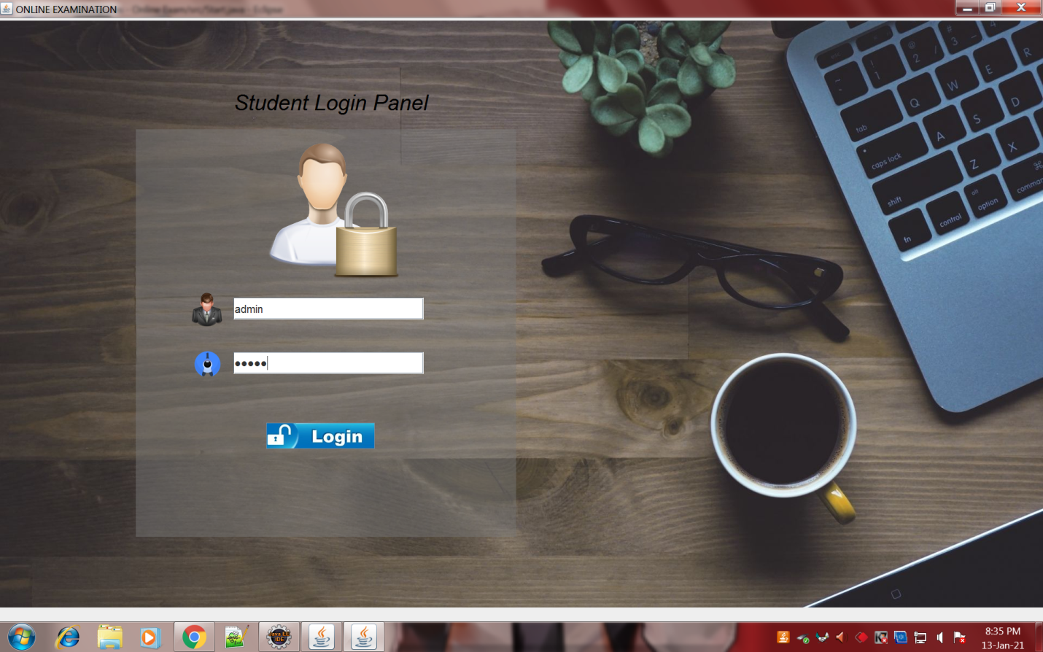

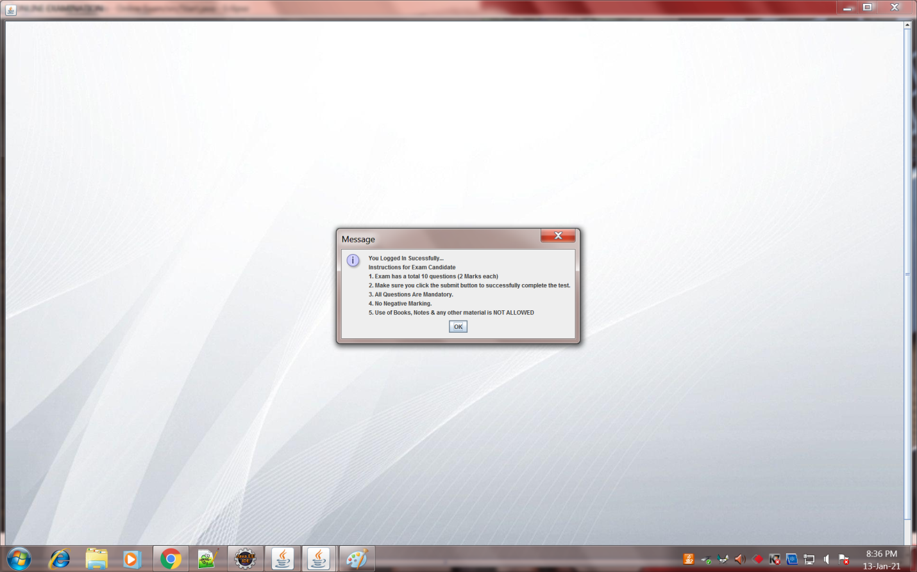

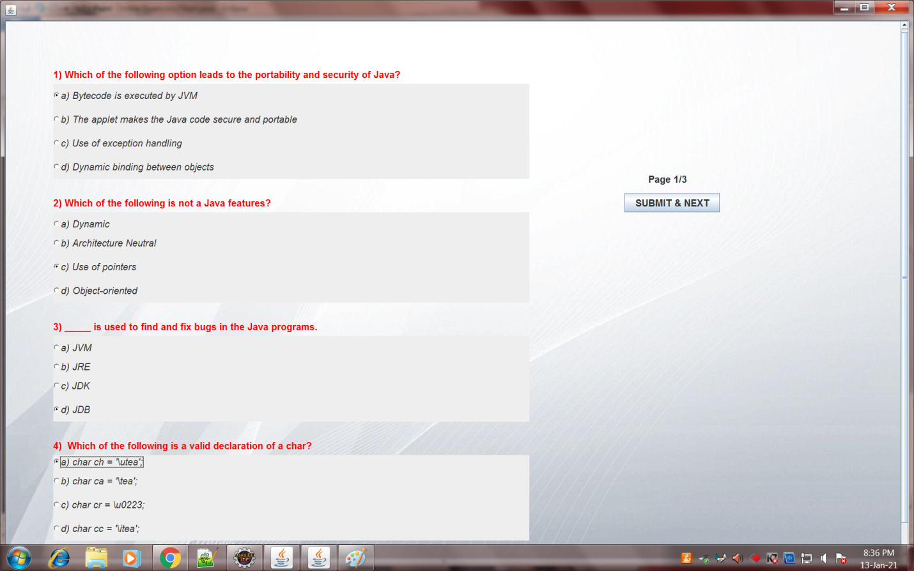

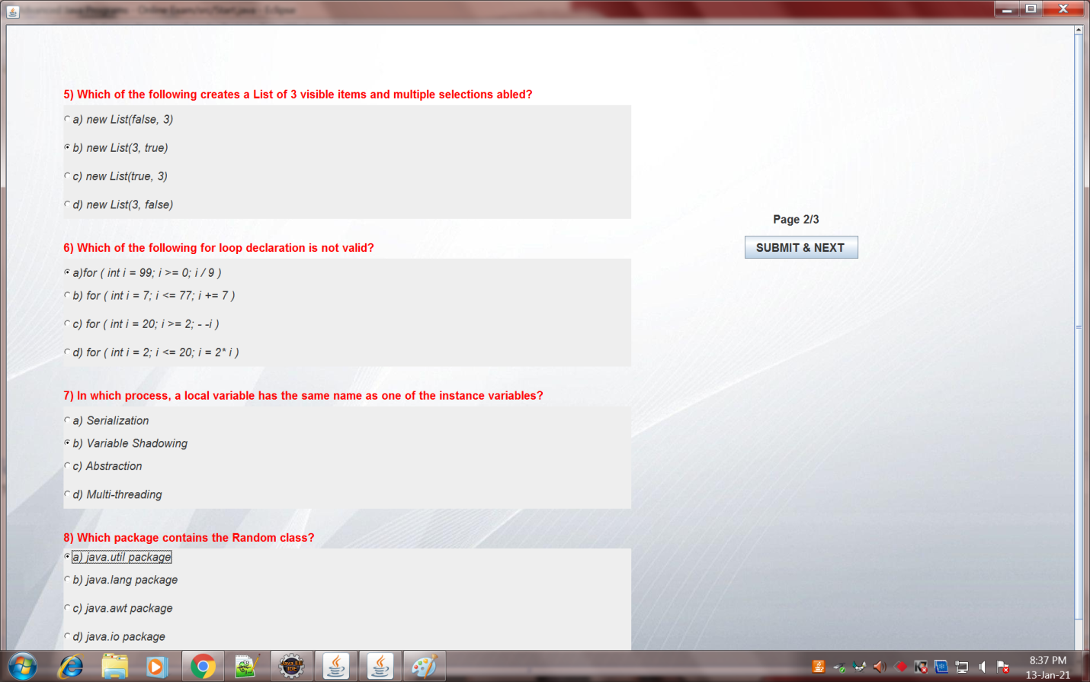

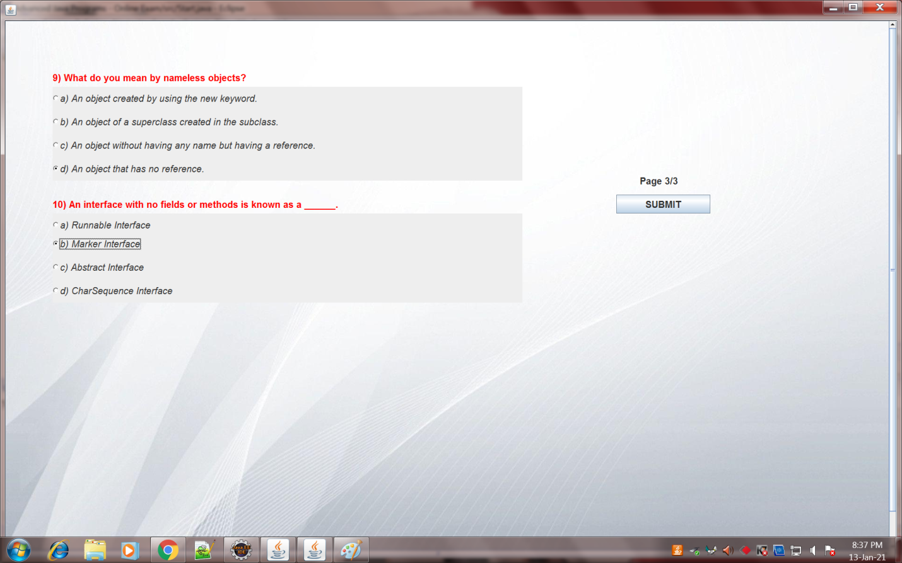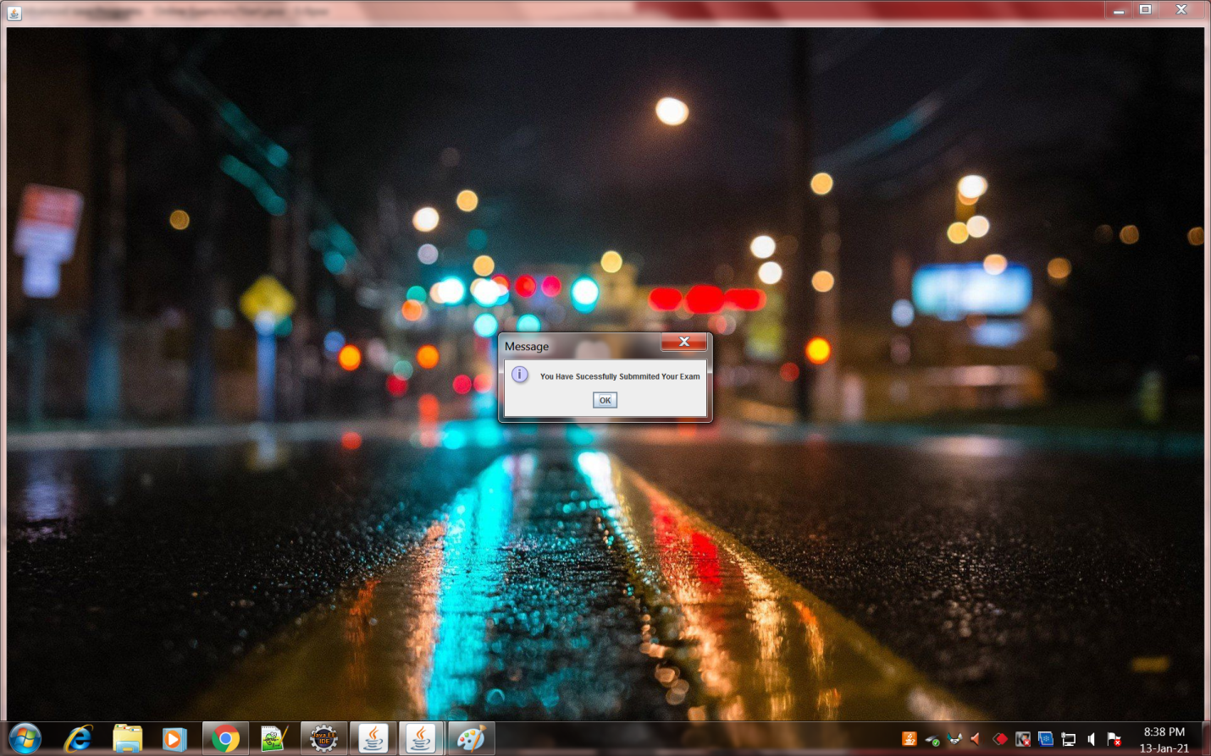

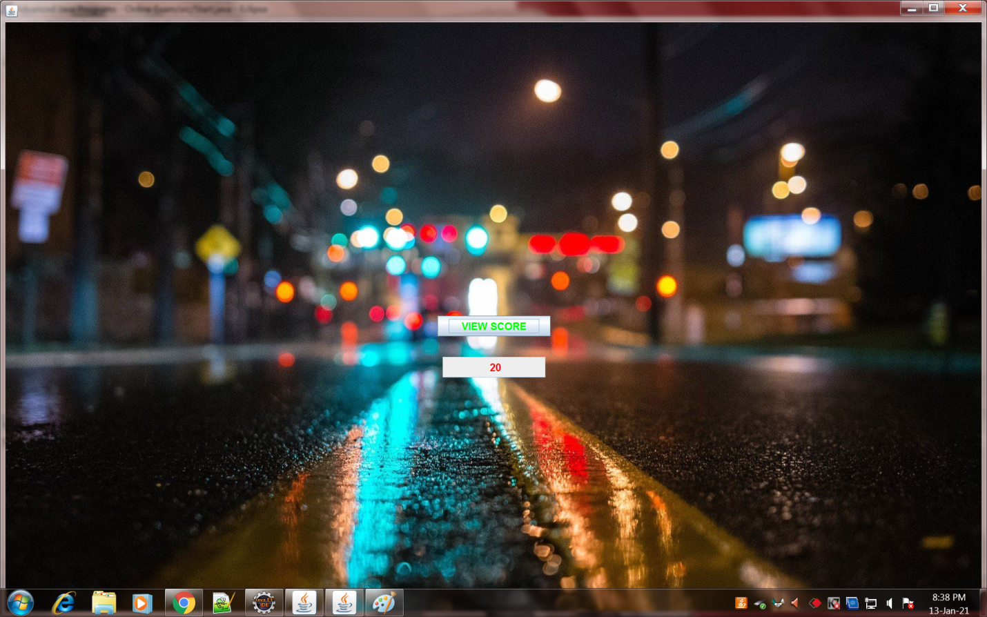

**THANK YOU**